Experiment No. 2
Signal Operations and Transformations
Aim:
To perform basic signal operations such as addition and multiplication, and to study signal transformations such as amplitude scaling, time compression, and time expansion using MATLAB

OBJECTIVE:
(i) To perform amplitude scaling and time scaling of continuous-time and discrete-time signals and analyze their effects on signal characteristics.
(ii) To perform time shifting and time reversal of continuous-time and discrete-time signals and analyze the resulting transformations.
(iii) To perform addition and multiplication of two discrete-time sequences and analyze the resulting signal characteristics.
(iv) To visualize and compare the original and transformed signals using MATLAB and interpret the effects of different signal operations.

- To perform amplitude scaling and time scaling of continuous-time and discrete-time signals and analyze their effects on signal characteristics.

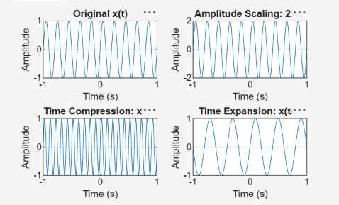

- To perform time shifting and time reversal of continuous-time and discrete-time signals and analyze the resulting transformations.

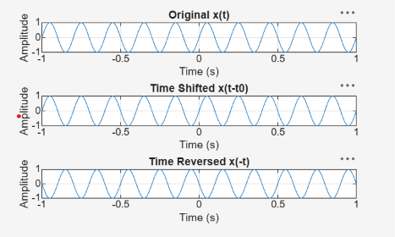

- To perform addition and multiplication of two discrete-time sequences and analyze the resulting signal characteristics

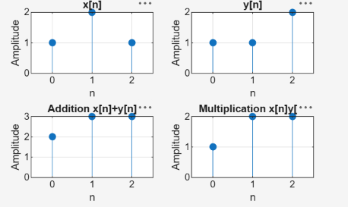

- To visualize and compare the original and transformed signals using MATLAB and interpret the effects of different signal operations.

